**WEEK-6**

1.Creating my first React application

Step1:Installing and Checking the version of node.js and npm

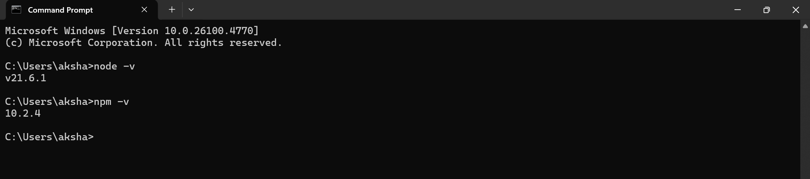

Step2:Installing Create React App and Creating React App with the name “myfirstreact”

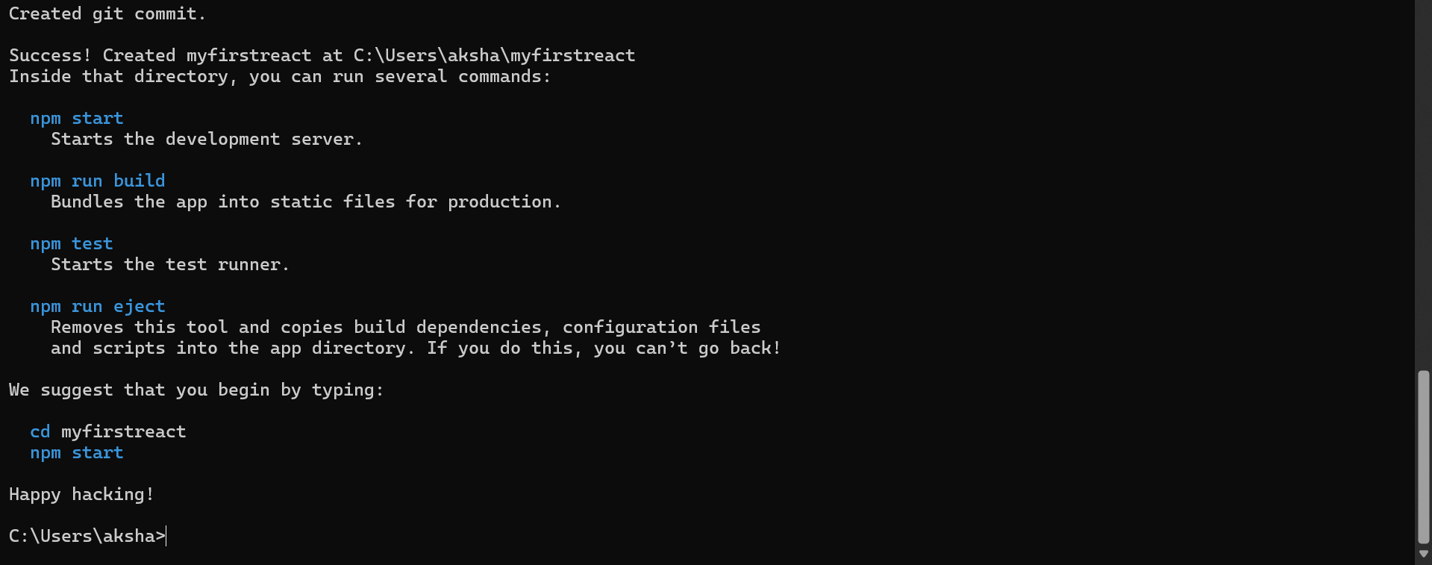

Step3:Navigating into the app folder

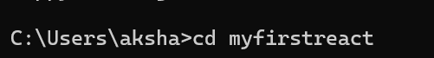

Step4:Opening the folder in VS Code

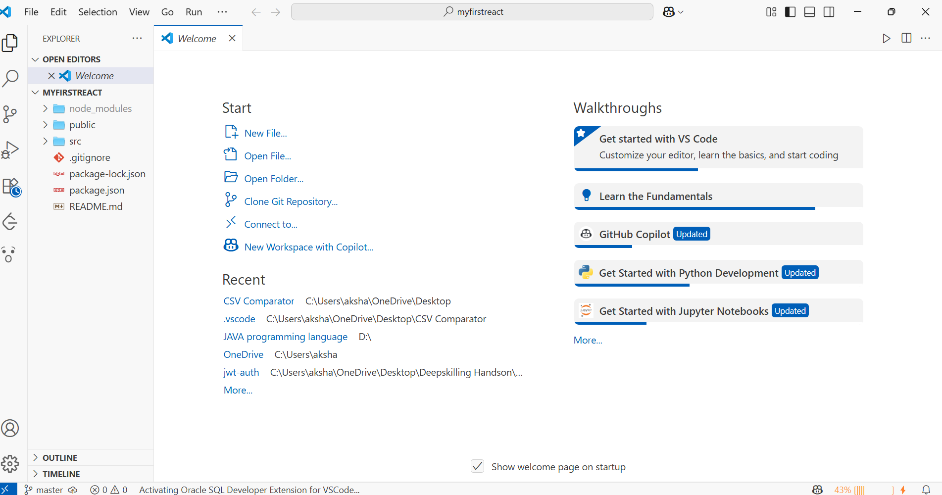

Step5:Modifying App.js

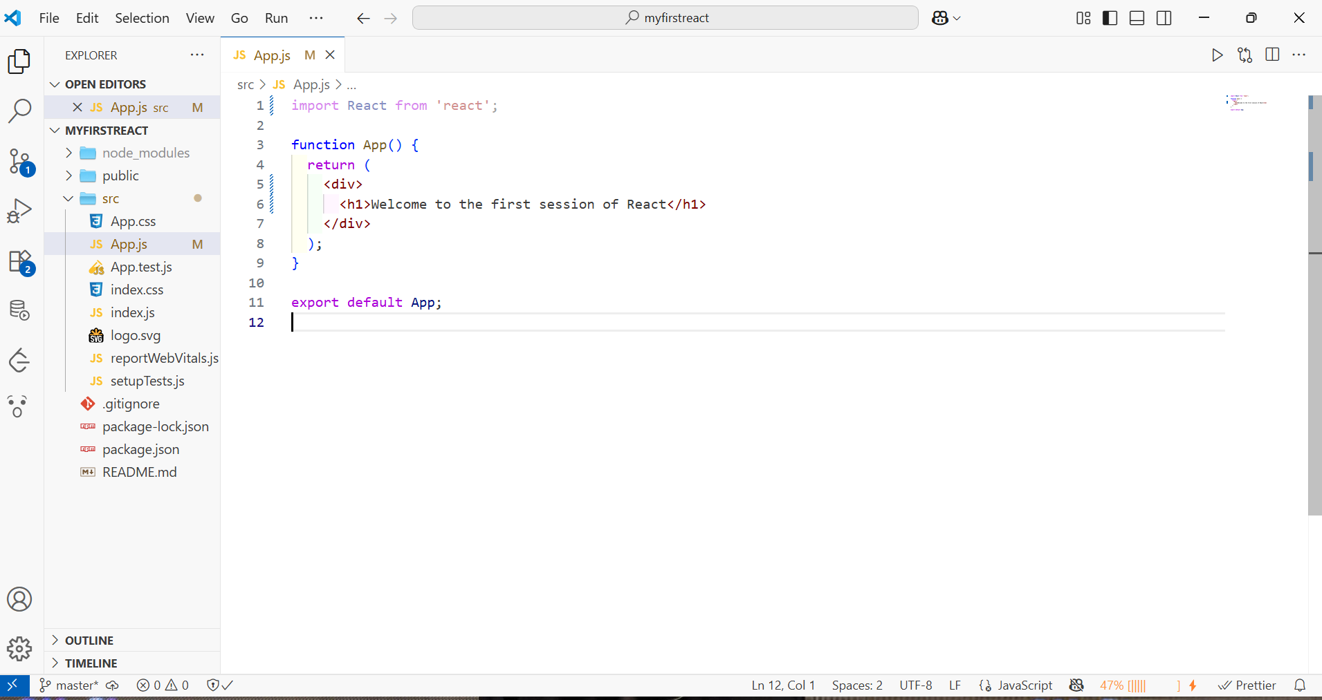

Step6:Starting the React application and viewing it in the browser

